Healthcare:

Trauma-Informed Systems Training

Online Trauma/Brain 101: Understanding the Impact of Trauma on Brain Development
Trauma/Brain Development 201: Building Resiliency
Recognizing & Managing Secondary Traumatic Stress

Trauma STARS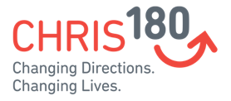
Connections Matter Georgia
CDC's Preventing Adverse Childhood Experiences
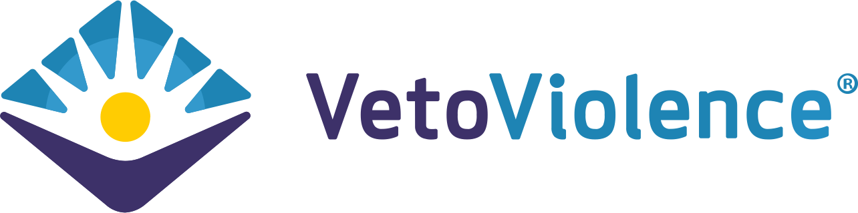
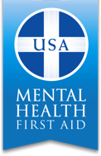
Adult Mental Health First Aid*
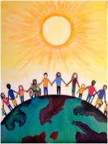
Community Resiliency Model
Second Victim Program (for MDs and RNs)
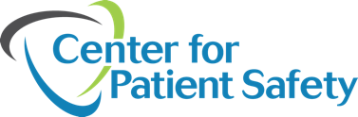
CDC's Preventing Adverse Childhood Experiences - Medical Provider Module (Coming Soon)
Attachment Self-Regulation & Competency
Compassion Integrity Training
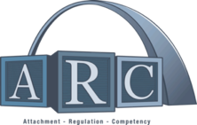
Sanctuary Model

Prevention Training
ASIST (Applied Suicide Intervention Skills Training)
Certified Peer Support
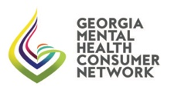
Child life Specialists
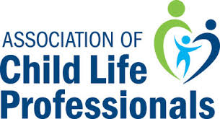

Compassion Integrity Training
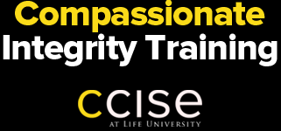

Cultural Humility Training
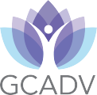

Human Trafficking Prevention

PCAGA's Mandated Reporter Training

Positive Parenting Program (Triple P)

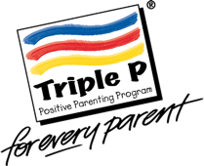

QPR (Question, Persuade, Refer)
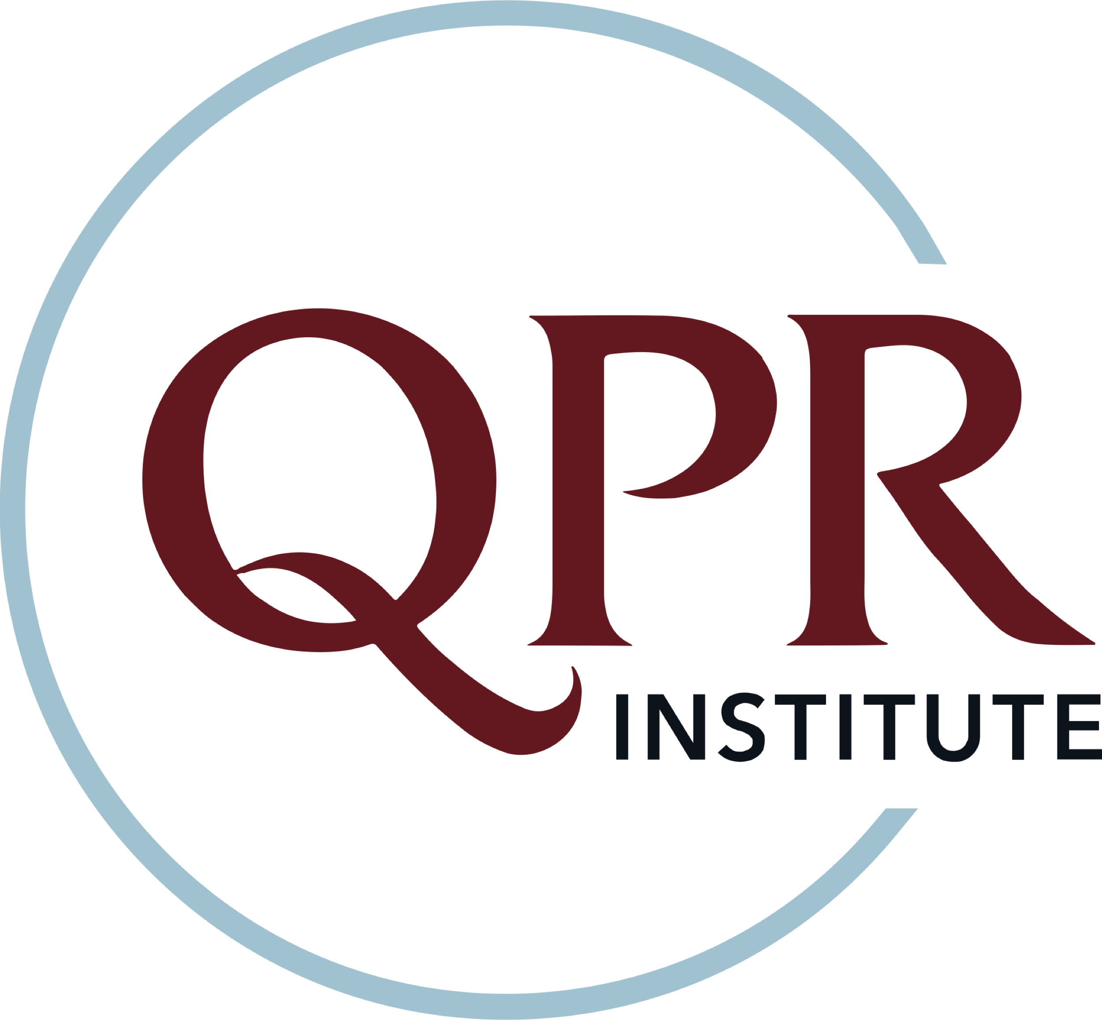
Safe Care
SafeTALK

Stengthening Families

Stewards of Children

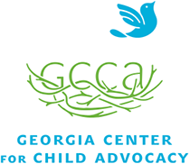

Strong for Life: Resiliency and Emotional Wellness

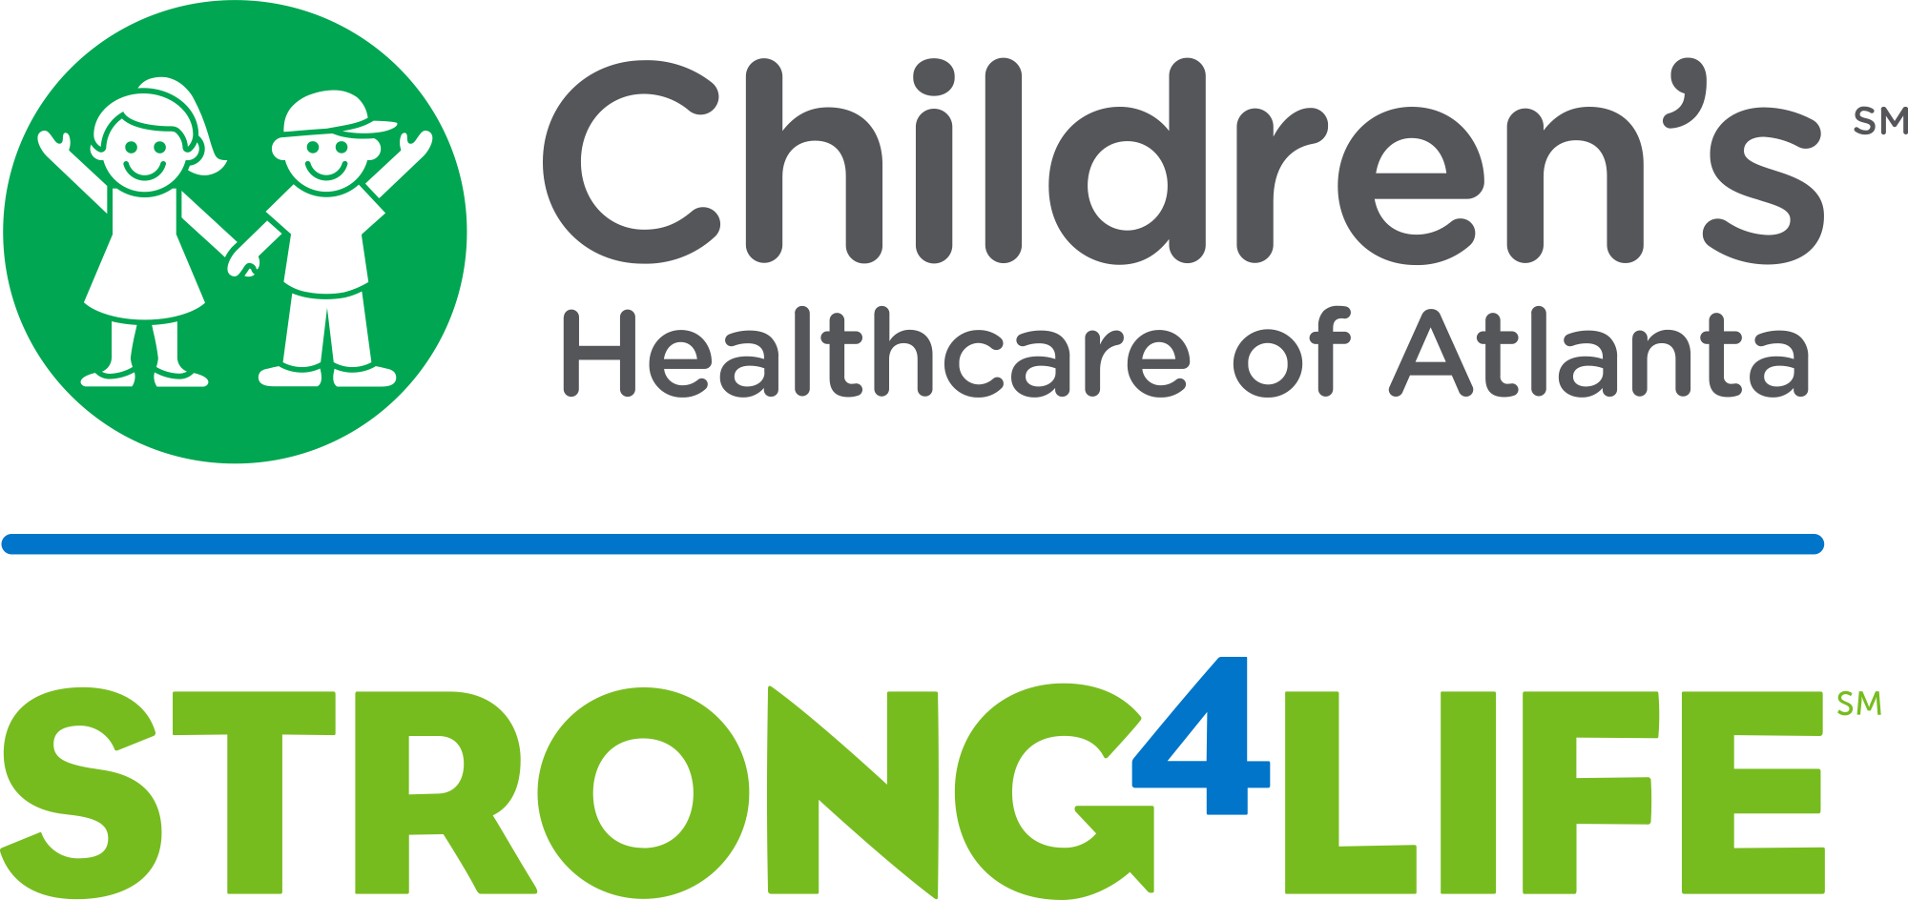

Talk to Me Baby

Two Generation Approach

Human Trafficking Prevention

Worksite Wellness Training
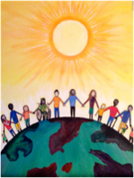
Community Resiliency Model
Compassion Integrity Training
Mindful Self-Compassion Training

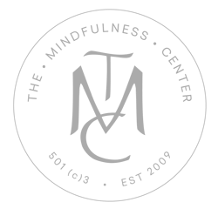
Mindfulness/ Yoga

Second Victim Program (MDs and RNs)
Trauma Resiliency Training
Compassion Fatigue 101: Online Course
Resilience in Trauma-Exposed Work Online Course
Recognizing & Managing Secondary Traumatic Stress
Total Worker Health
