Community
Trauma-Informed Systems Training

Online Trauma/Brain 101: Understanding the Impact of Trauma on Brain Development
Trauma/Brain Development 201: Building Resiliency
Recognizing & Managing Secondary Traumatic Stress

Trauma STARS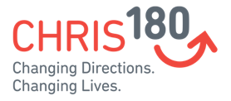
Connections Matter Georgia

CDC's Preventing Adverse Childhood Experiences
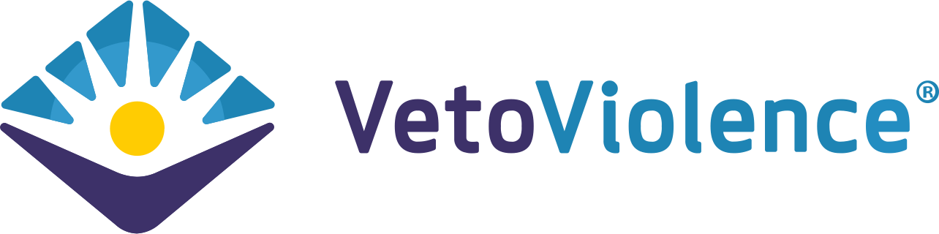

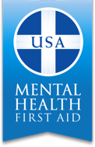
Adult Mental Health First Aid*

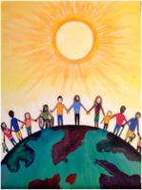
Community Resiliency Model
Compassion Integrity Training
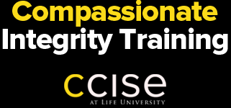
Community Resilience Initiative Trainings
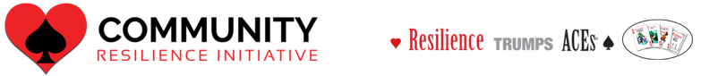

Prevention Training

Compassion Integrity Training
Cultural Humility Training

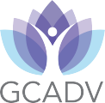

Ending the Silence
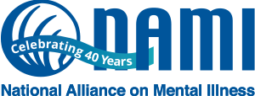

Human Trafficking Prevention

Lifting Latinx Voices Initiative
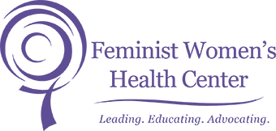
SafeTALK
Stewards of Children
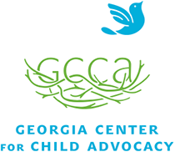

Strong for Life: Resiliency and Emotional Wellness
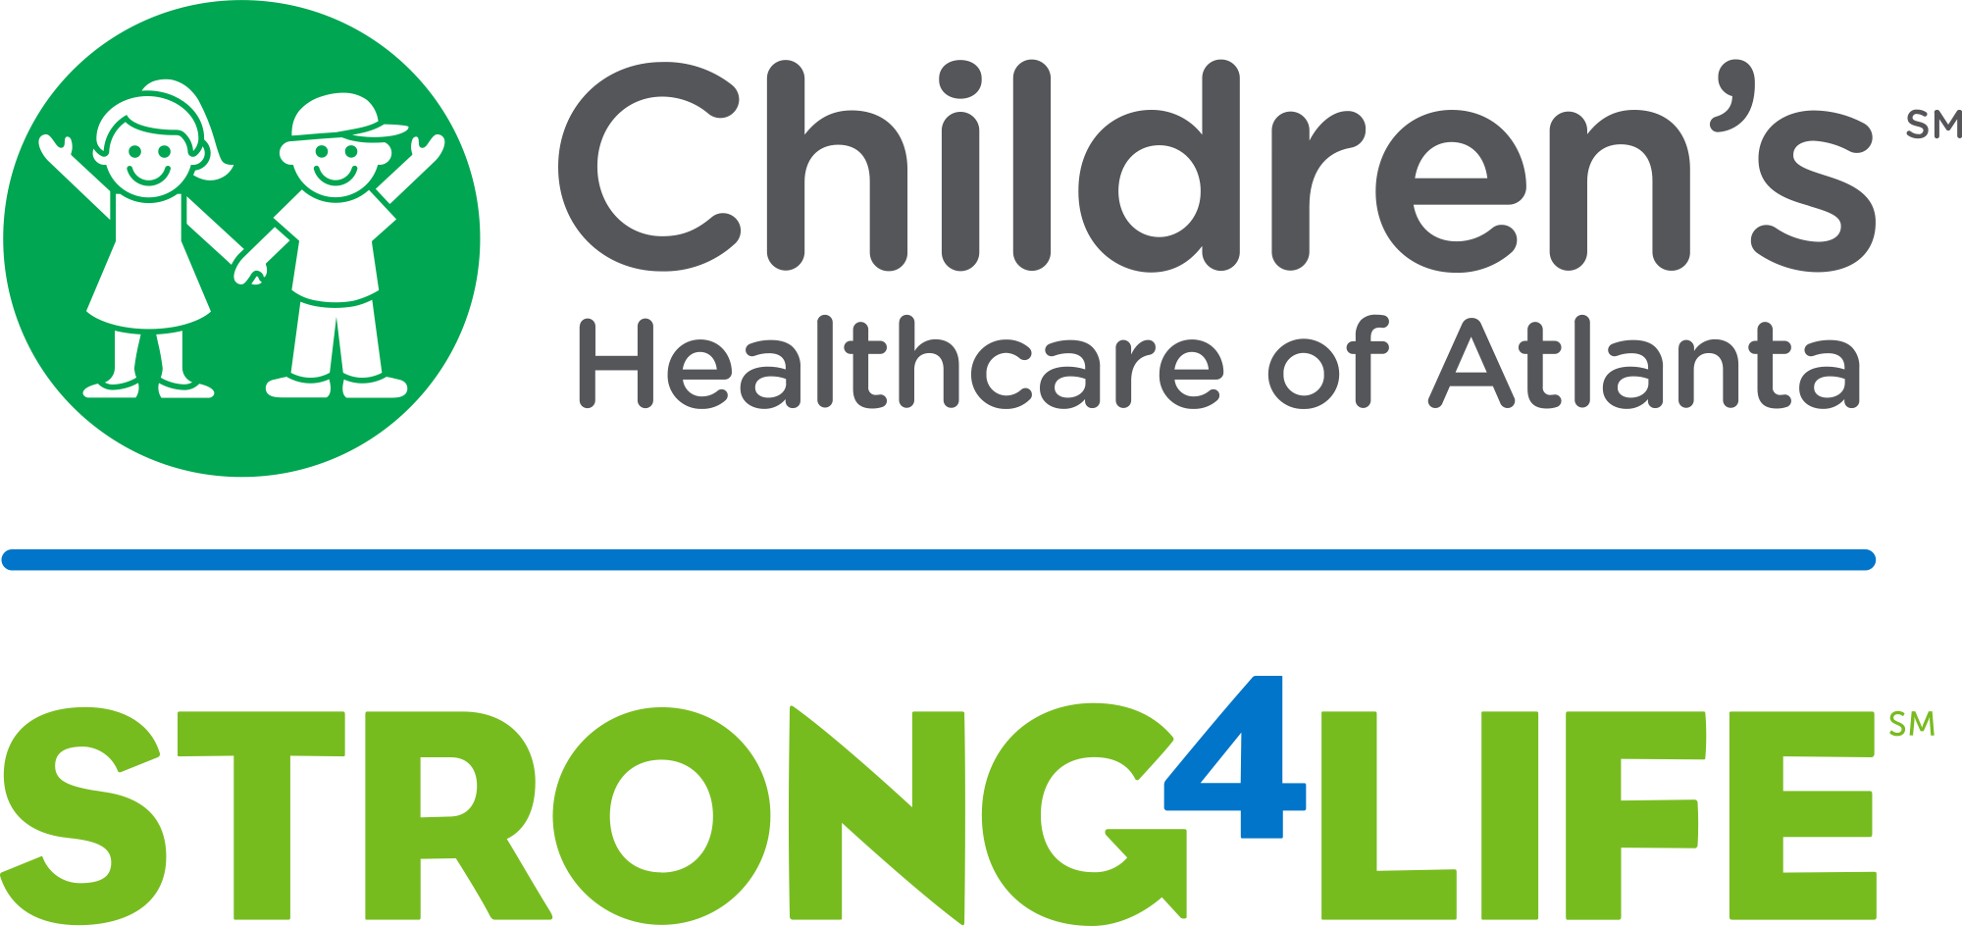

Two Generation Approach

Human Trafficking Prevention

Worksite Wellness Training

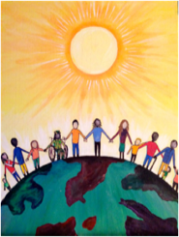
Community Resiliency Model
Compassion Integrity Training
Healing Circles
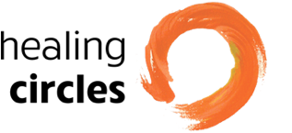
Mindful Self-Compassion Training
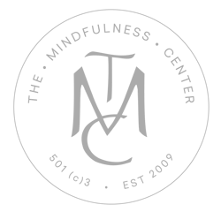
Mindfulness/ Yoga
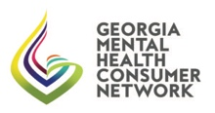
Peer Support

Trauma Resiliency Training

Youth Yoga and Mindfulness Training
