Businesses
Trauma-Informed Systems Training

Online Trauma/Brain 101: Understanding the Impact of Trauma on Brain Development
Trauma/Brain Development 201: Building Resiliency

Trauma STARS 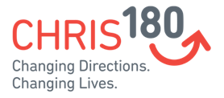

Connections Matter Georgia
CDC's Preventing Adverse Childhood Experiences
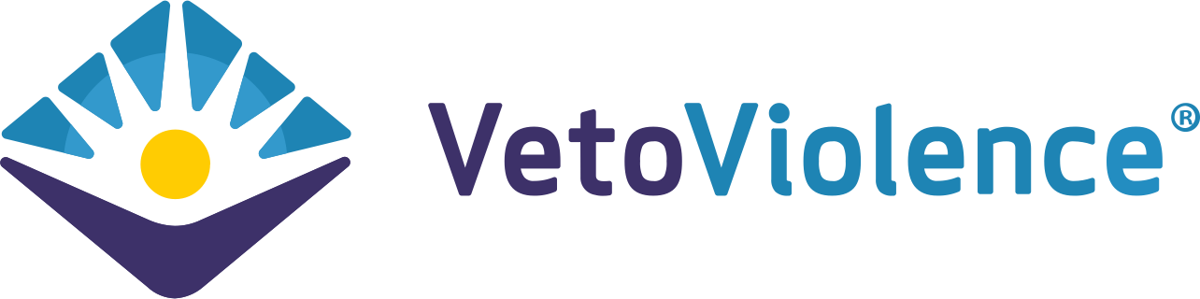

Adult Mental Health First Aid*
Compassion Integrity Training

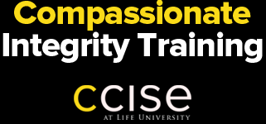

Prevention Training

Compassion Integrity Training

Cultural Humility Training
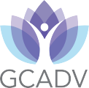

Human Trafficking Prevention

SafeTALK

Stewards of Children

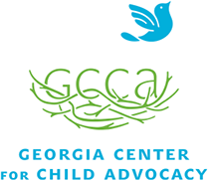

Human Trafficking Prevention

Worksite Wellness Training

Recognizing & Managing Secondary Traumatic Stress
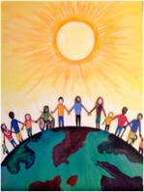
Community Resiliency Model

Compassion Integrity Training
Mindful Self-Compassion Training
Mindfulness/ Yoga

Trauma Resiliency Training
Total Worker Health
