Faith Based

Trauma-Informed Systems Training

Online Trauma/Brain 101: Understanding the Impact of Trauma on Brain Development
Trauma/Brain Development 201: Building Resiliency
Recognizing & Managing Secondary Traumatic Stress

Trauma STARS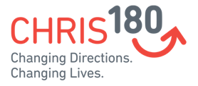

Connections Matter Georgia

CDC's Preventing Adverse Childhood Experiences
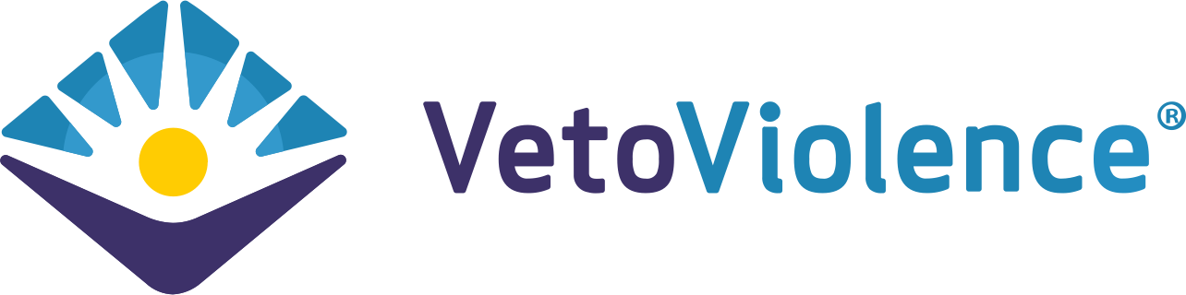

Adult Mental Health First Aid*

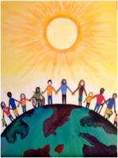
Community Resiliency Model
Trust Based Relational Intervention

Attachment Self-Regulation & Competency

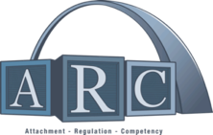

Compassion Integrity Training

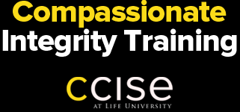

Prevention Training
Compassion Integrity Training

Cultural Humility Training
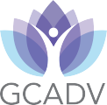

SafeTALK

Human Trafficking Prevention

PCAGA's Mandated Reporter Training

QPR (Question, Persuade, Refer)
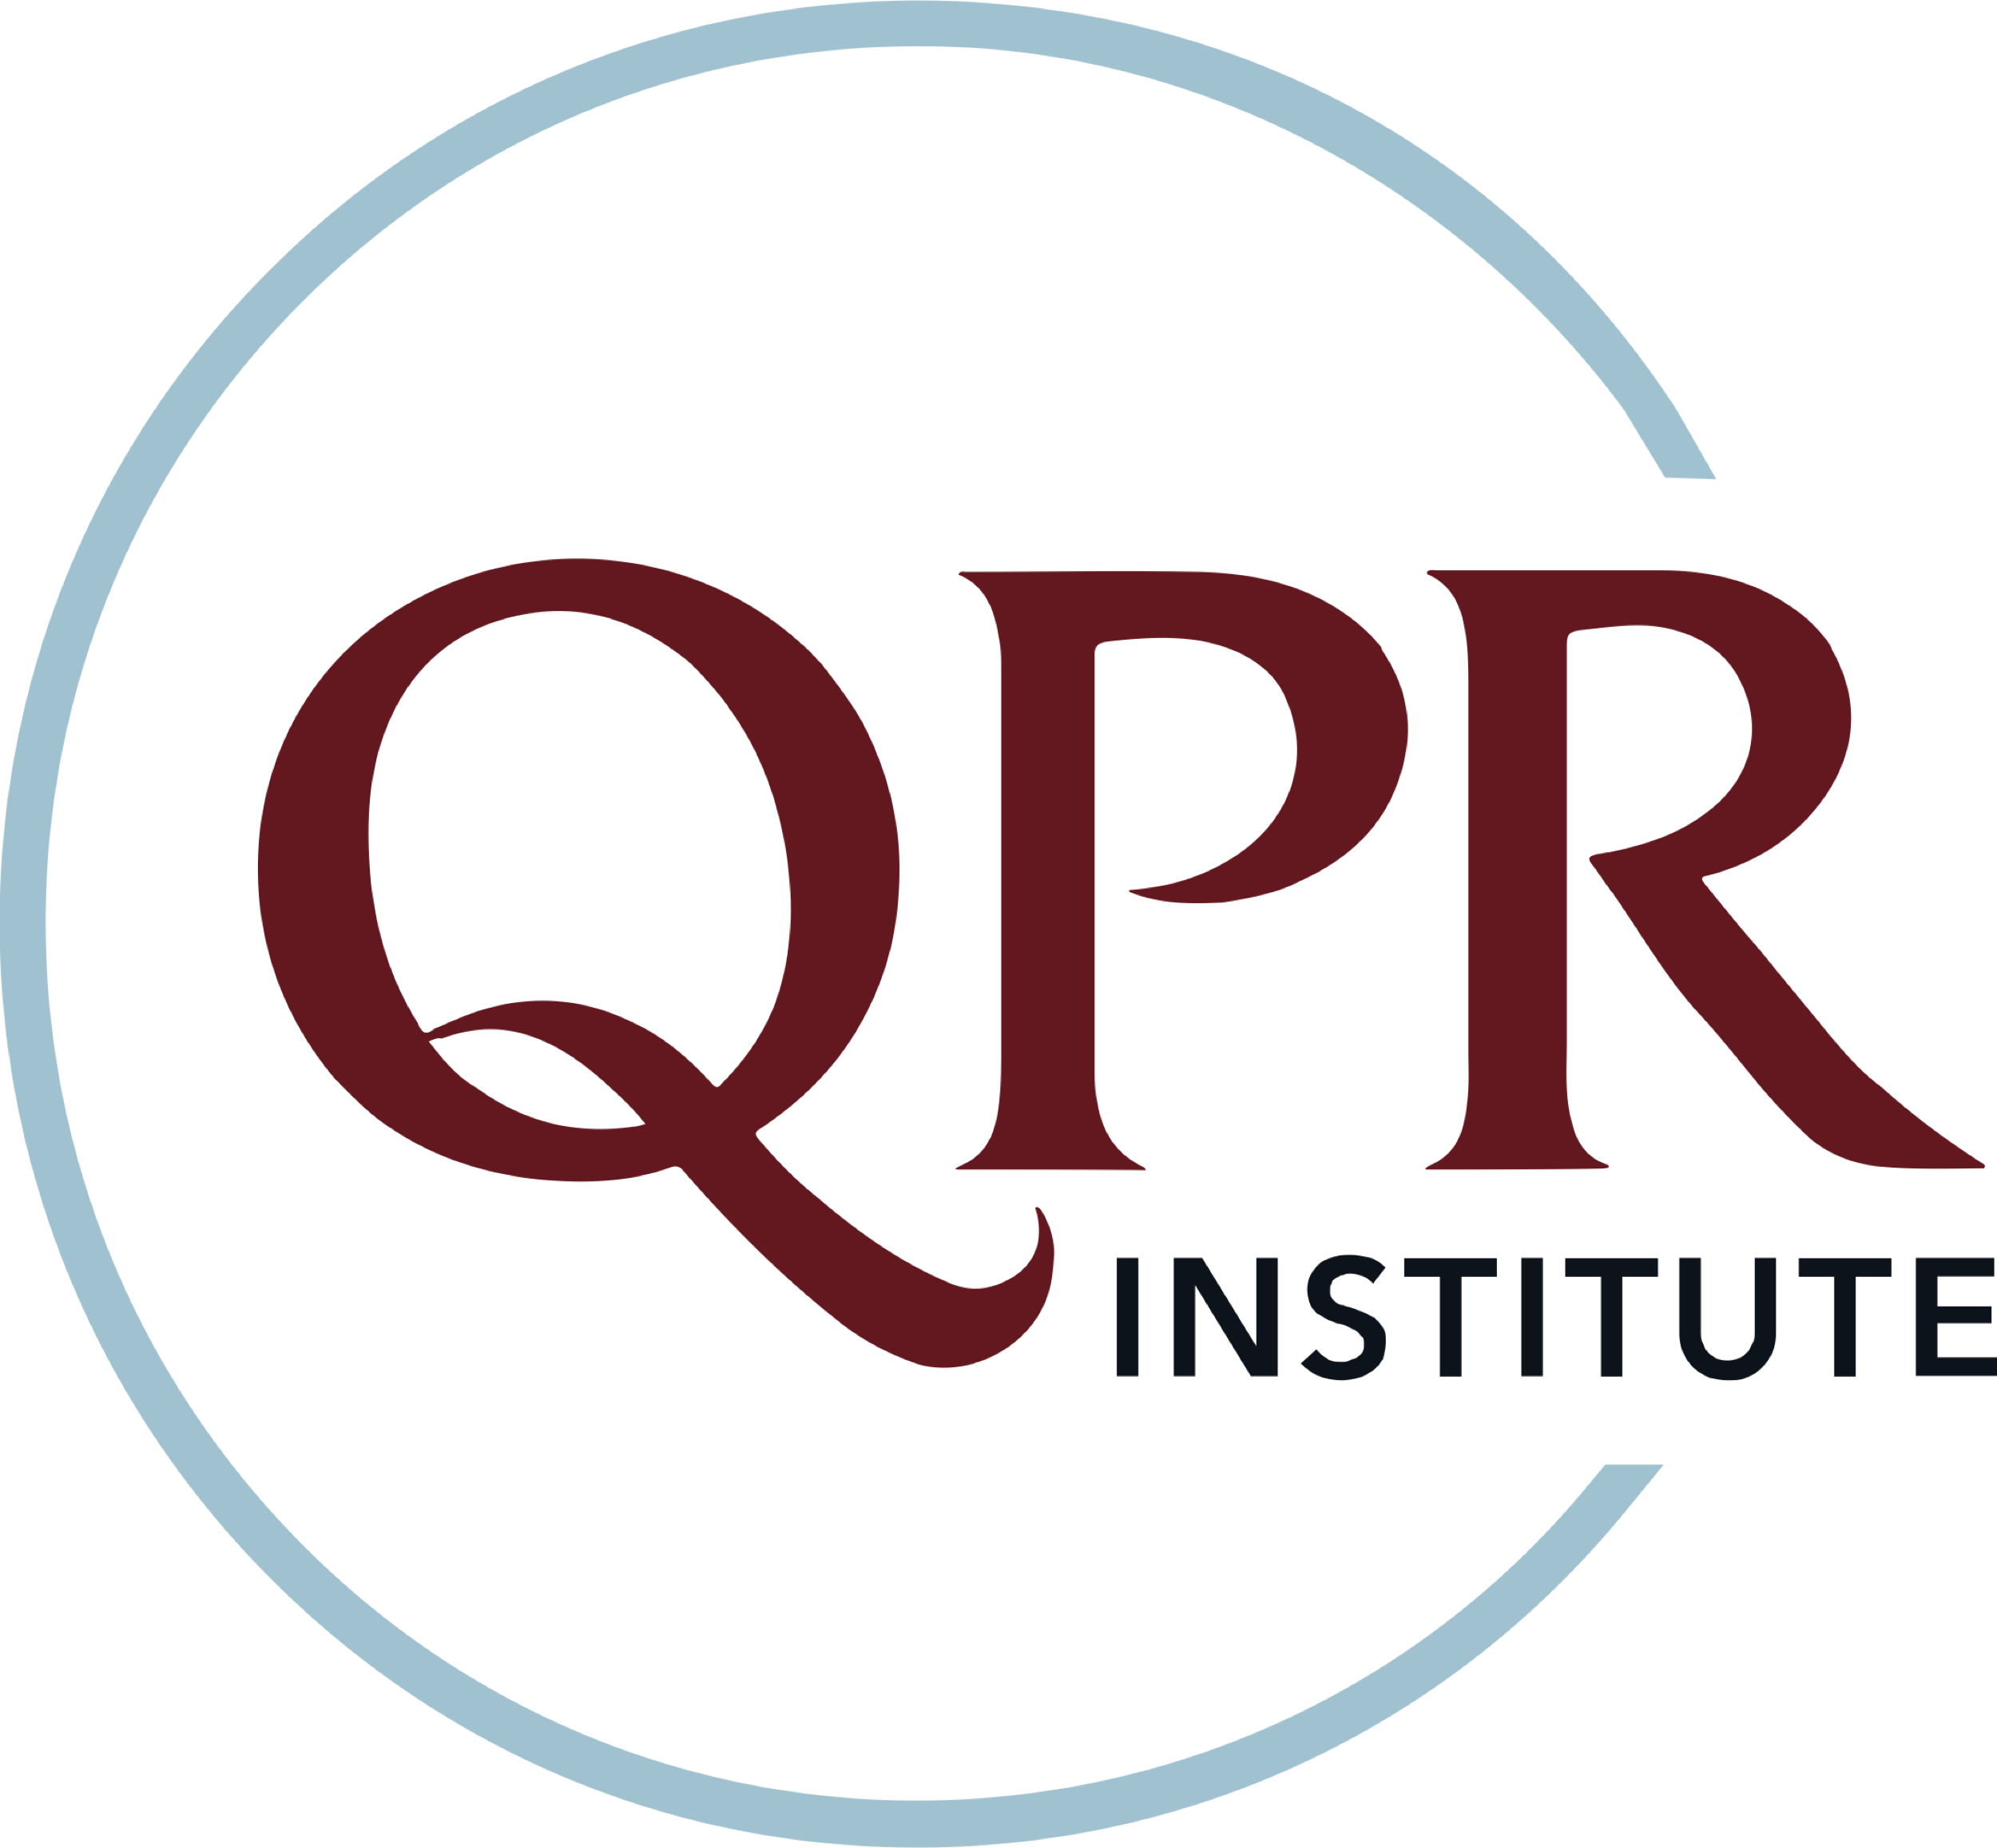
Stengthening Families

Stewards of Children
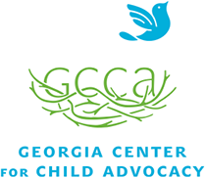

Strong for Life: Resiliency and Emotional Wellness

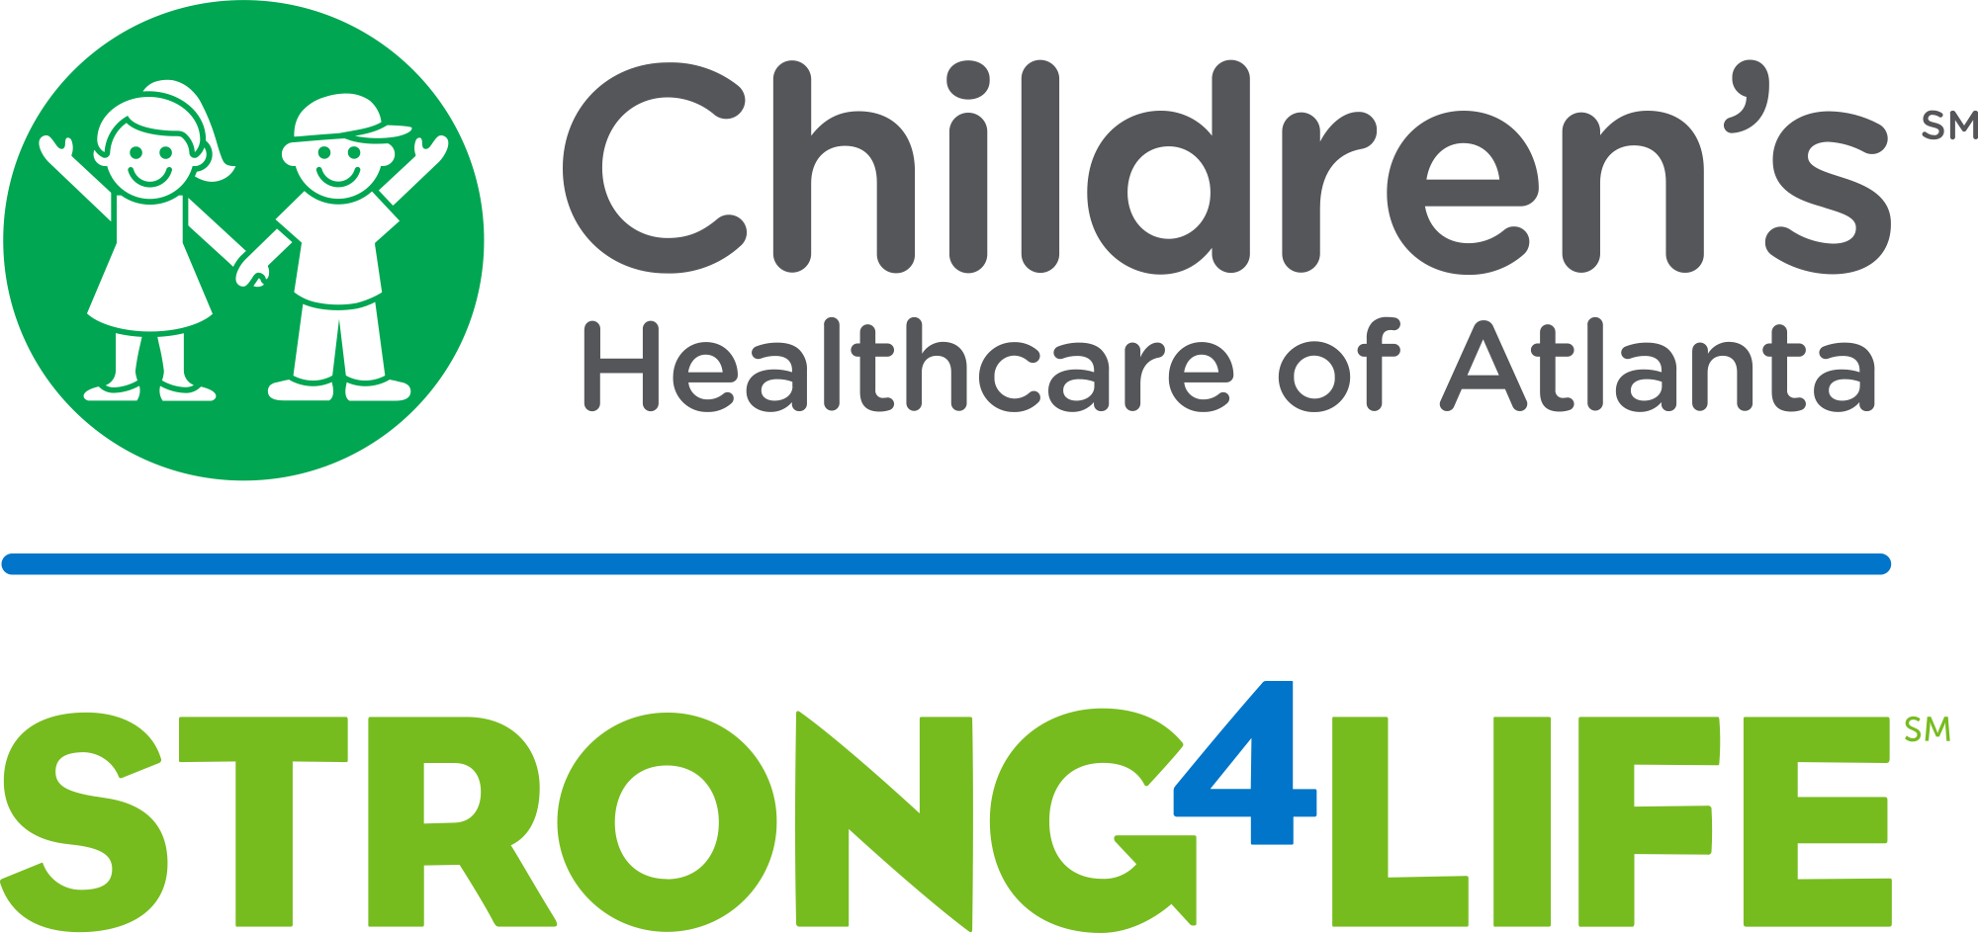

Two Generation Approach

Human Trafficking Prevention

Worksite Wellness Training
Community Resiliency Model
Compassion Integrity Training
Mindful Self-Compassion Training
Mindfulness/ Yoga

Peer Support

Trauma Resiliency Training
Youth Yoga and Mindfulness Training
Compassion Fatigue 101: Online Course
Resilience in Trauma-Exposed Work Online Course
Recognizing & Managing Secondary Traumatic Stress

