Juvenile Justice
Trauma-Informed Systems Training

Online Trauma/Brain 101: Understanding the Impact of Trauma on Brain Development
Trauma/Brain Development 201: Building Resiliency
Recognizing & Managing Secondary Traumatic Stress

Trauma STARS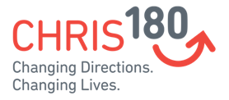
Connections Matter Georgia
CDC's Preventing Adverse Childhood Experiences
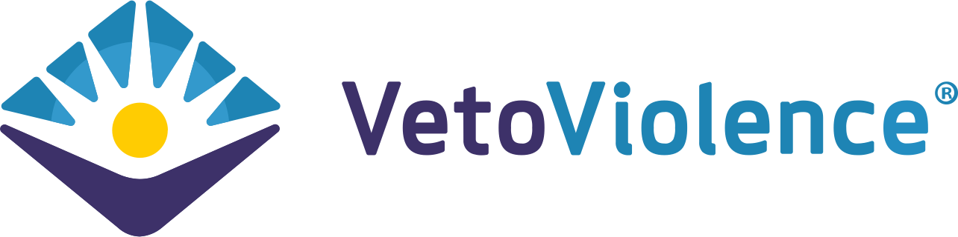
Adult Mental Health First Aid*
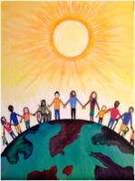
Community Resiliency Model
Trust Based Relational Intervention

Attachment Self-Regulation & Competency
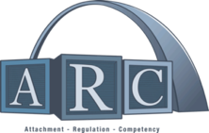

Compassion Integrity Training

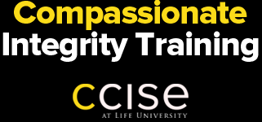

Sanctuary Model

Prevention Training
Certified Peer Support
Compassion Integrity Training

Cultural Humility Training
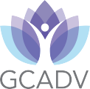

Differences are Good (Equity and Inclusion)
Handle With Care Plan

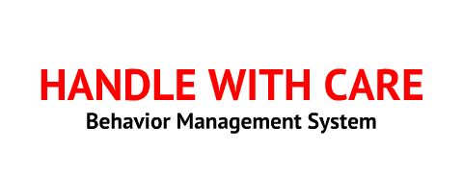

Human Trafficking Prevention

PCAGA's Mandated Reporter Training

Safe Care
Stengthening Families

Stewards of Children

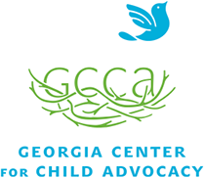

Strong for Life: Resiliency and Emotional Wellness

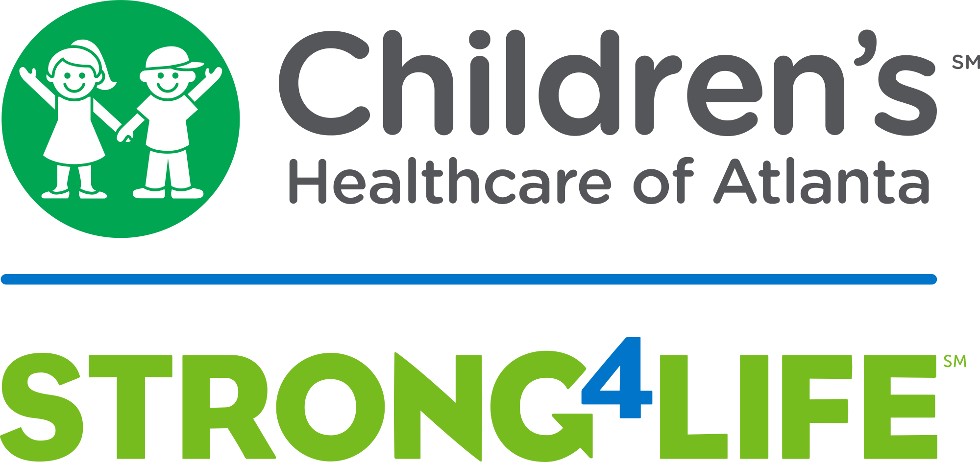

Two Generation Approach

Human Trafficking Prevention

Worksite Wellness Training
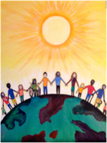
Community Resiliency Model
Compassion Integrity Training
Differences are Good (Equity and Inclusion)
Mindful Self-Compassion Training
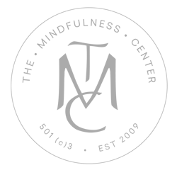
Mindfulness/ Yoga

Trauma Resiliency Training
Youth Yoga and Mindfulness Training
Compassion Fatigue 101: Online Course
Resilience in Trauma-Exposed Work Online Course
Recognizing & Managing Secondary Traumatic Stress
Total Worker Health
