Youth
Trauma-Informed Systems Training

Online Trauma/Brain 101: Understanding the Impact of Trauma on Brain Development
Trauma/Brain Development 201: Building Resiliency
Connections Matter Georgia (Grades 9-12 only)
CDC's Preventing Adverse Childhood Experiences
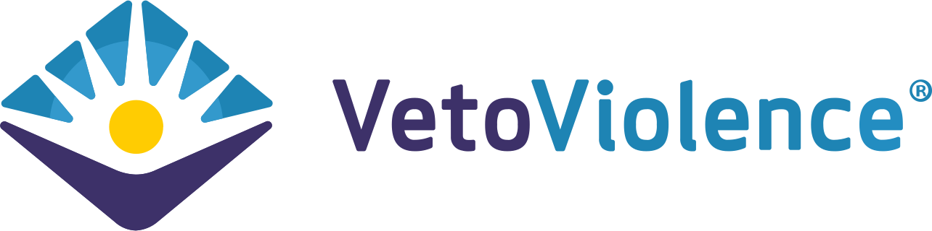
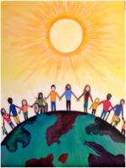
Community Resiliency Model
CIT - Youth/ Youth in Crisis
Compassion Integrity Training
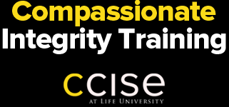

Prevention Training

Child Safety Matters (K-5)/Teen Safety Matters (6-12)
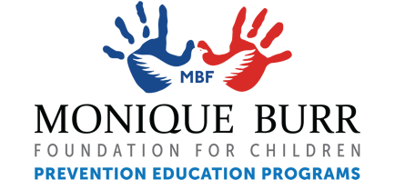
Compassion Integrity Training

Cultural Humility Training

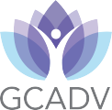

GCAPP - WISE program (6-12)
Guide Inc. Youth Development Substance Use and Abuse Prevention
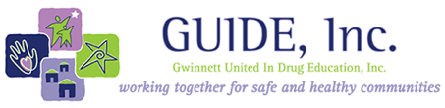
Love146 - Not A Number (6-12)
PADV's Teen Dating Violence Prevention
SB401 (Erin's Law) Curricula

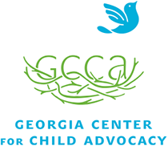

Second Step (K-12)
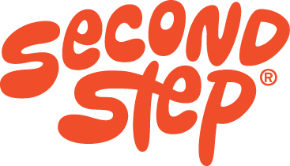
SEE Learning

Signs of Suicide
Sources of Strength
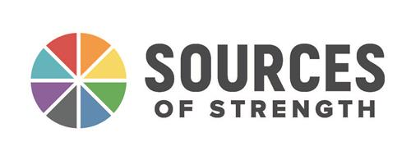
UGA's Relationship Smarts
UNL Leadership Academy

Worksite Wellness Training
Mind Yeti
Captain Compassion
Sesame Street: Little Children Big Challenges

